**Chapter-7**

## **Memory devices**

## **1.0 RAM (Random-access memory)**

* A random-access memory device allows data items to be read or written in almost the same amount of time irrespective of the physical location of data inside the memory. RAM contains multiplexing and demultiplexing circuitry, to connect the data lines to the addressed storage for reading or writing the entry.

RAM is normally associated with volatile types of memory (such as DRAM modules), where stored information is lost if power is removed, although non-volatile RAM has also been developed.

## **1.1 Static RAM and Dynamic RAM**

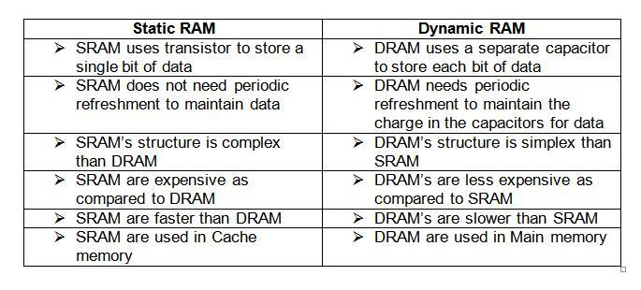

## **1.2 Applications of SRAM & DRAM**

### **SRAM**

* + SRAM is also used in personal computers, workstations, routers and peripheral equipment: CPU register files, internal CPU caches and external burst modeSRAM caches, hard disk buffers, router buffers, etc.
  + LCD screens and printers also normally employ static RAM to hold the image displayed (or to be printed). Static RAM was used for the main memory of some early personal computers such as the ZX80, TRS-80 Model 100 and Commodore VIC-20.

### **DRAM**

* + Cell Phones
  + Desktop Computers
  + Digital Signal Controller (DSC)
  + Global Positioning System (GPS)
  + Personal Data Assistant (PDA)
  + Smartphones
  + Tablets and Pads

## **1.3 DIMM, DOWN memory (SDRAM)**

### DIMM(dual in-line memory module)

* + In general small outline dual in-line memory module (SO-DIMM).
  + A **DIMM** or **dual in-line memory module** comprises a series of dynamic random-access memory integrated circuits.

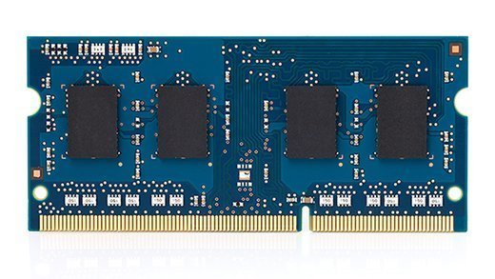**fig-1:SO-DIMM RAM**

These modules are mounted on a [printed circuit board](https://en.wikipedia.org/wiki/Printed_circuit_board) and designed for use in [personal computers](https://en.wikipedia.org/wiki/Personal_computer), [workstations](https://en.wikipedia.org/wiki/Workstation) and [servers](https://en.wikipedia.org/wiki/Server_(computing)). DIMMs began to replace [SIMMs](https://en.wikipedia.org/wiki/SIMM) (single in-line memory modules) as the predominant type of memory module as [Intel](https://en.wikipedia.org/wiki/Intel) [P5](https://en.wikipedia.org/wiki/P5_(microarchitecture))-based [Pentium](https://en.wikipedia.org/wiki/Pentium_(brand)) processors began to gain market share.

### DDR DIMMs

[DDR](https://en.wikipedia.org/wiki/DDR_SDRAM), [DDR2](https://en.wikipedia.org/wiki/DDR2_SDRAM), [DDR3](https://en.wikipedia.org/wiki/DDR3_SDRAM) and [DDR4](https://en.wikipedia.org/wiki/DDR4_SDRAM) all have different pin counts, and different notch positions. As of August, 2014, DDR4 SDRAM is a modern emerging type of dynamic random access memory (DRAM) with a high-bandwidth ("double data rate") interface, and has been in use since 2013. It is the higher-speed successor to DDR, DDR2 and DDR3. DDR4 SDRAM is neither forward nor backward compatible with any earlier type of random access memory (RAM) because of different signalling voltages, timings, as well as other differing factors between the technologies and their implementation.

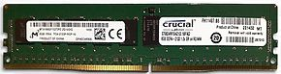**fig-2 DDR DIMM**

## **1.4 Form factors**

Several form factors are commonly used in DIMMs. Single Data Rate Synchronous DRAM (SDR SDRAM) DIMMs were primarily manufactured in 1.5 inches (38 mm) and 1.7 inches (43 mm) heights. When [1U rackmount](https://en.wikipedia.org/wiki/Rack_unit) servers started becoming popular, these form factor registered DIMMs had to plug into angled DIMM sockets to fit in the 1.75 inches (44 mm) high box. To alleviate this issue, the next standards of DDR DIMMs were created with a "low profile" (LP) height of around 1.2 inches (30 mm). These fit into vertical DIMM sockets for a 1U platform.

## **1.5 SDRAM**

* SD-RAM (Synchronous dynamic random-access memory)
  + Also call it as down memory
  + where the operation of its external pin interface is coordinated by an externally supplied clock signal.

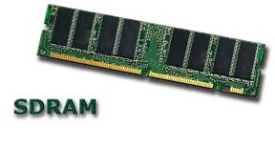

## **1.6 DDR,DDR2,DDR3,DDR4**

## Image result for ddr ddr2 ddr3 ddr4

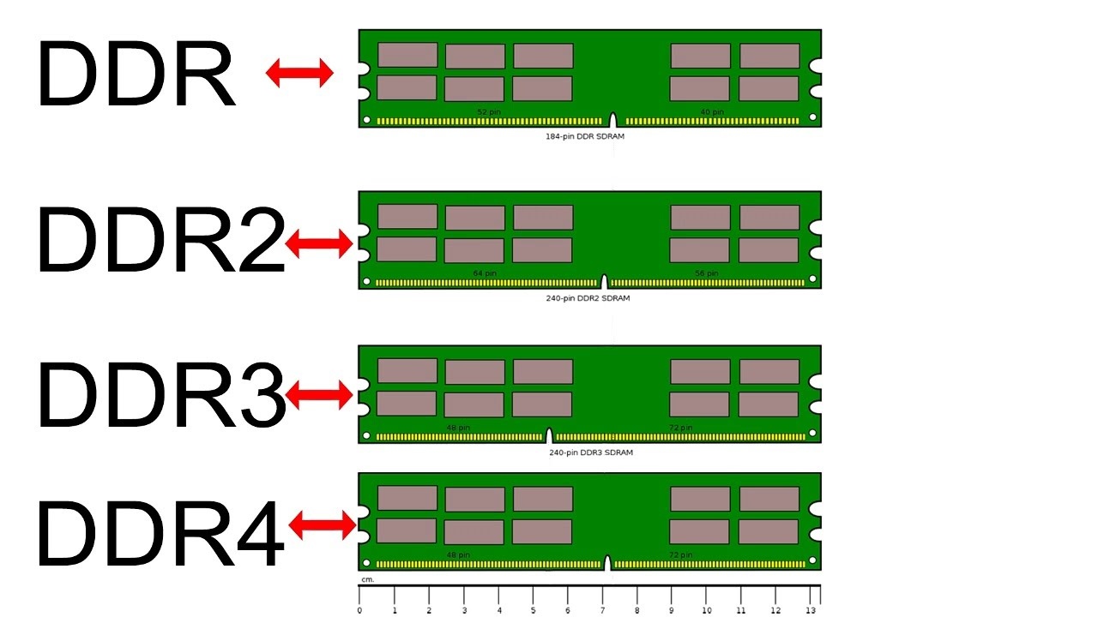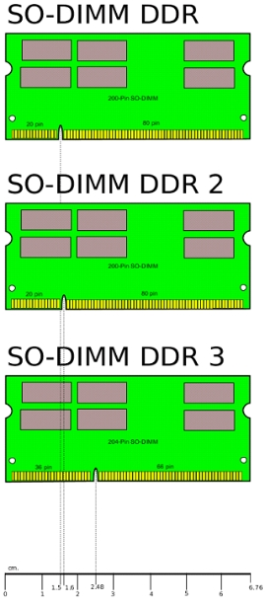

**Fig-3:DDR form factors**

**1.7 Dual channel and single channel**

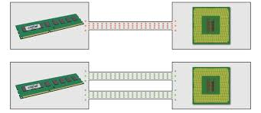**fig-4:Dual Channel between RAM and controller**

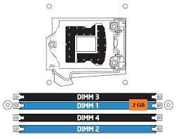

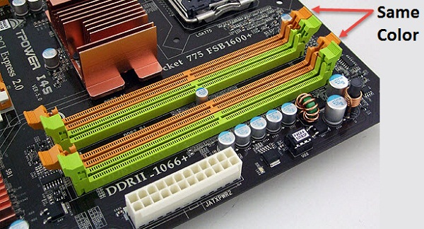

The **RAM** in the system is **controlled by a circuit that is referred to as Memory Controller.** The RAM and the Memory Controller are connected through a series of wires, collectively known as a Memory Bus. Now, these wires are further divided into three groups – **Control, Data, and Address.**The Control wires are responsible for sending the commands to the memory modules, which contain information about what kind of operation is being performed by the system. The Data wires will carry the data that is either being read from the memory to the memory controller or being written from the memory controller to the memory

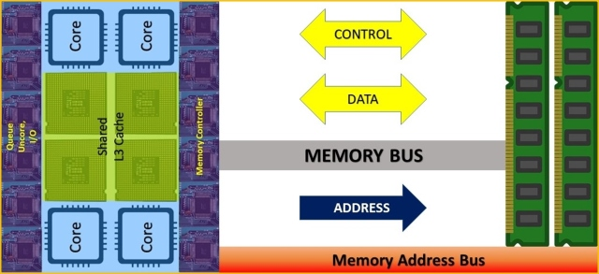

## **1.8 How to use 2 RAM with different frequency?**

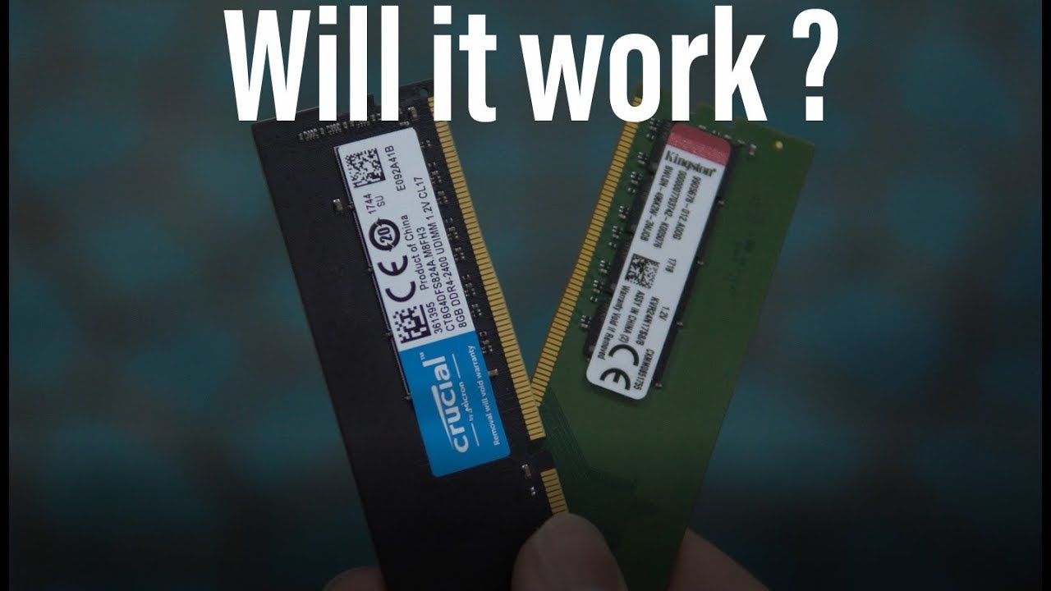

* Both RAM will choose the lowest speed among themselves.
* And mainly the higher frequency RAM should be in the 1st slot else they won’t configure.

## **2.0 ROM stands for Read Only Memory**

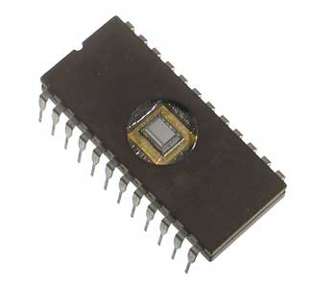

* The memory from which we can only read but cannot write on it.
* This type of memory is non-volatile.
* A ROM stores such instructions that are required to start a computer. This operation is referred to as **bootstrap**.

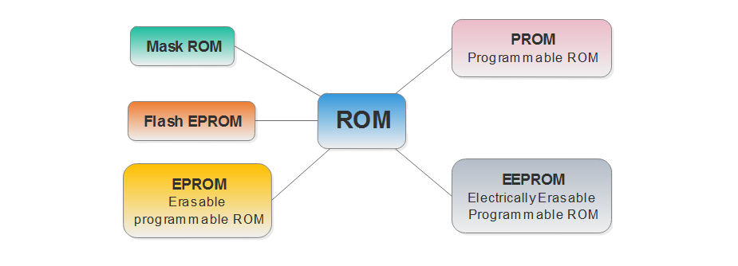

## **2.1 MROM (Masked ROM)**

* The very first ROMs were hard-wired devices that contained a pre-programmed set of data or instructions.
* These kind of ROMs are known as masked ROMs, which are inexpensive.

## **2.2 PROM (Programmable Read Only Memory)**

* PROM is read-only memory that can be modified only once by a user.
* The user buys a blank PROM and enters the desired contents using a PROM program.
* Inside the PROM chip, there are small fuses which are burnt open during programming. It can be programmed only once and is not erasable.

## **2.3 EPROM (Erasable and Programmable Read Only Memory)**

* EPROM can be erased by exposing it to ultra-violet light for a duration of up to 40 minutes.
* The charge is retained for more than 10 years because the charge has no leakage path.
* For erasing this charge, ultra-violet light is passed through a quartz crystal window (lid).

## **2.4 EEPROM (Electrically Erasable and Programmable Read Only Memory)**

* EEPROM is programmed and erased electrically. It can be erased and reprogrammed about ten thousand times.
* Both erasing and programming take about 4 to 10 ms (millisecond).
* In EEPROM, any location can be selectively erased and programmed. EEPROMs can be erased one byte at a time, rather than erasing the entire chip. Hence, the process of reprogramming is flexible but slow.

## **2.5 FLASH ROM**

* **Flashrom** is a universal flash programming utility used to detect, read, verify, erase, or write BIOS chips in dual in-line package.
* It supports parallel, Low Pin Count (LPC), FWH, and Serial Peripheral Interface Bus (SPI) flash interfaces. It can be used to flash firmware images such as BIOS or coreboot, or to backup an existing firmware.

## **2.6 Advantages of ROM**

The advantages of ROM are as follows −

* Non-volatile in nature
* Cannot be accidentally changed
* Cheaper than RAMs
* Easy to test
* More reliable than RAMs
* Static and do not require refreshing
* Contents are always known and can be verified

**STORAGE DEVICES**

Categorized as

* + 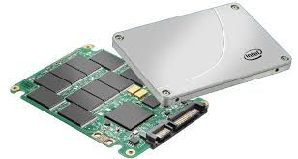Floppy Disk Drive
  + Hard Disk Drive
  + Optical Drives
  + Removable Storage

## **3.0 HARD DISK DRIVES**

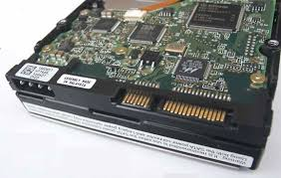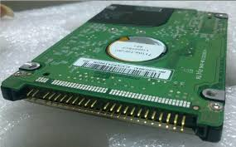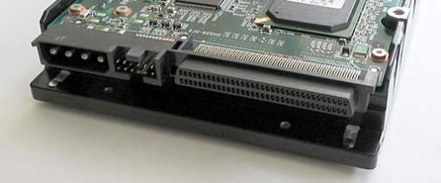 **Fig-5:Harddisk**

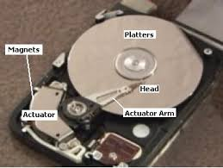

* A hard disk is a sealed unit containing a number of platters in a stack
* n a hard disk, data is stored in thin, concentric bands. A drive head, while in one position can read or write a circular ring, or band called a track.
* Sections within each track are called sectors. A sector is the smallest physical storage unit on a disk.
* A cluster can consist of one or more consecutive sectors. The number of sectors is always an exponent of 2



**Fig-6:Internal of Harddisk**

**1.Primary Partition:**

•Windows operating systems must be located in a primary partition.

• Only primary partitions can be used to boot the Operating system.

**2.Extended Partition:**

•A hard disk may contain only one extended partition.

•the extended partition can be subdivided into multiple logical

partitions (Other than OS is a Extended Partition).

**3.Logical Partition:**

•Linux operating systems can be installed into (and run from)

logical partitions.

**4.Active Partition:**

•Only one partition on a computer can be set as an **active**

**partition** or **bootable partition**.

•For example, if you are using Microsoft Windows the partition

that contains Windows is the active partition.



**Cluster**

Grouping sectors into larger blocks are called **clusters** .

**Master Boot Record (MBR)**

The location of the master boot record is cylinder 0, head 0, and sector 1.

**DOS Boot Record (DBR)**

In the beginning of the boot drive the DOS boot record will load .

**Boot Sector**

The two tasks of boot sector is to load in the operating system and to inform the user

## **3.1 Hard Disk Interfaces**

* ST-506/412
* ESDI
* IDE
* EIDE
* SCSI
* **Integrated Drive Electronics** (**IDE)/EIDE**

It is used to attach Mass Storage media devices to the computer.

* **The next generations of IDE interface is Enhanced IDE (EIDE)**
* **Small Computer System Interface (SCSI)**
* It is capable of supporting up to 7 to 15 devices.
* **Serial ATA (SATA)**
* It is an internal or inside-the-box interface technology.
* External SATA is commonly known as ESATA.
* **USB**
* It is an External , pocket Hard-disk

***Serial Advanced Technology Attachment***

* a standard for connecting and transferring data from hard disk drives (HDDs) to computer systems
* SATA is based on serial signaling technology, unlike Integrated Drive Electronics (IDE) hard drives that use parallel signaling.
* succeeds the older Parallel ATA (PATA) offering several advantages
  + reduced cable size and cost

(7 conductors instead of 40 or 80),

* + native hot swapping
  + faster data transfer through higher

signaling rates

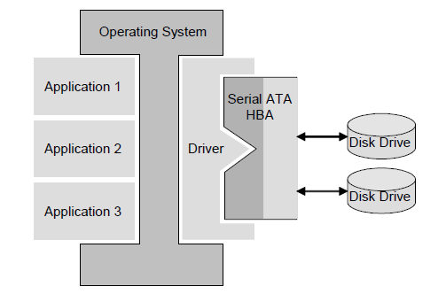

## **3.2 SATA v/s PATA**

|  |  |  |
| --- | --- | --- |
| **Parameters** | **SATA** | **PATA** |
| Data transfer rate | 150 – 600 Mbps | Up to 133Mbps |
| Sustained Throughput | 55 Mbps | 52 Mbps |
| Cable pins | 7 | 40 |
| Cable length | 40 inched(1 meter) | 18n inches |
| Hot pluggable | Yes | No |
| Power consumptionRead/WriteIdleStandby/ Sleep | 1.60.650.20 | 2.20.950.25 |
| Power connect pins | 15 pins | 4 pins |
| Jumper settings | No | Yes |

## 

### **eSATA**- for external connectivity

is an extension to the Serial ATA standard that enables SATA drives to be attached externally.

Prior to eSATA, external hard drives were connected via USB 2.0 or FireWire. While eSATA can provide faster transfer rates than USB or FireWire, it requires its own power connector.

### **mSATA**- mini SATA

An mSATA SSD has a smaller form factor than a standard SSD and is designed for use with portable, power-constrained devices such as laptops, tablets and netbooks.

An mSATA SSD is roughly the size of a business card. Advantages of mSATA SSDs include the small form factor, low power consumption, shock/vibration resistance and fast boot/shutdown capabilities

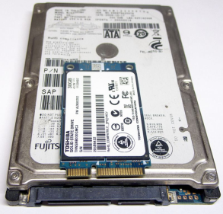 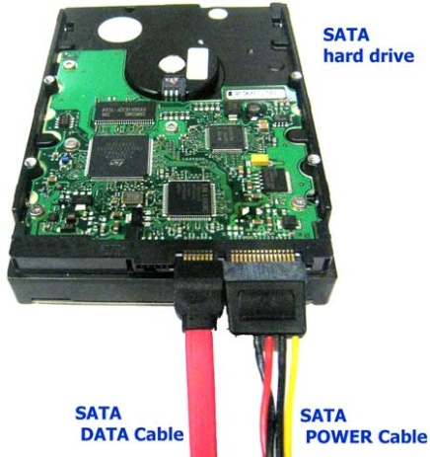

**Fig-7:An mSATA SSD on top of a 2.5-inch SATA drive**

## **4.0 Optical Disc Drives**

* is a flat, circular disc which encodes binary data in the form of pits (0) and lands (1) on special material on one of its flat surfaces
* optical discs are usually between 7.6 and 30 cm (3 to 12 in) in diameter and about 1.2 mm (0.05 in) thick
* designed to support one of three types:
  + read-only (e.g.: CD and CD-ROM)
  + recordable (write-once, e.g. CD-R)
  + re-recordable (rewritable, e.g. CD-RW)
* different types
  + ***Compact Disk (CD)***
  + ***Digital Versatile Disk (DVD)***
  + ***Blu-ray Disk (BD)***

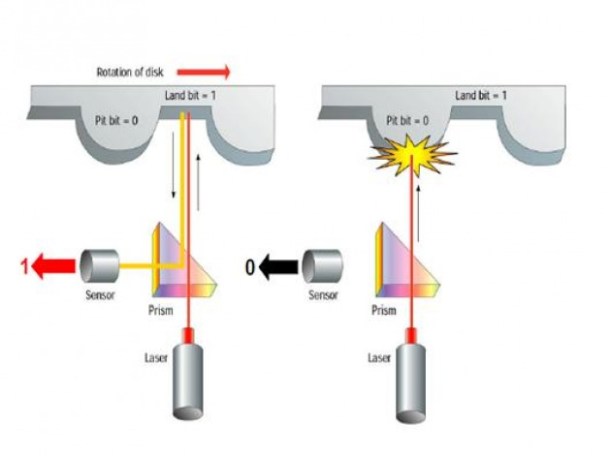

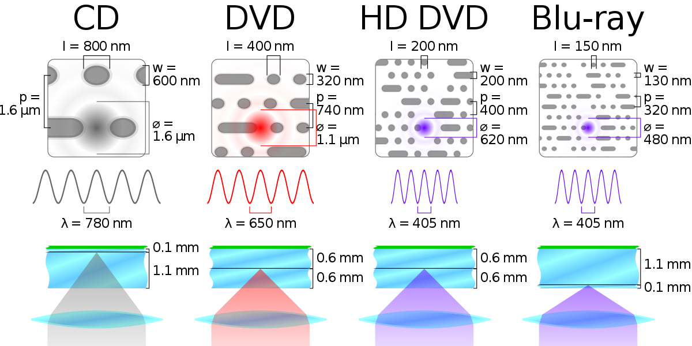

**Fig-8:Optical Disk Drive wavelength**

## **4.1 Flash memory**

* **Flash memory** is an electronic non-volatile computer storage device that can be electrically erased and reprogrammed.
* Flash memory developed from EEPROM (electrically erasable programmable read-only memory).
* There are two main types of flash memory, which are named after the NAND and NOR logic gates.
* The internal characteristics of the individual flash memory cells exhibit characteristics similar to those of the corresponding gates.

## **5.0 Removable Storage**

* + *Compact Flash Card*
  + *Memory stick*
  + *USB Storage Device*
  + *MMC devices*
  + *SD Card*
  + *Universal Flash Storage*

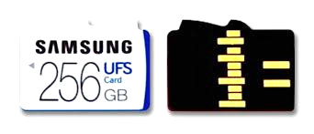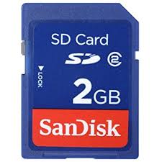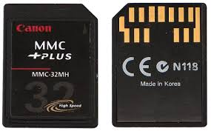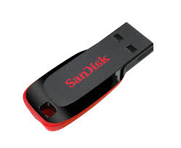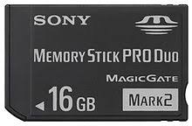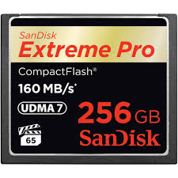

## **5.1 Multi Media Card**

* is a memory card standard used for solid-state storage
* about the size of a postage stamp: 24 mm × 32 mm × 1.4 mm.
* an MMC is used as a storage medium for a portable device, in a form that can easily be removed for access by a PC.
* MMCs are available in sizes up to and including 512 GB

## **5.2 (eMMC)embedded Multi Media Card**

* widely used in the industry as a primary means of

integrated storage in portable devices

* low-cost flash memory system
* Contains 3 parts
  + The MMC interface
  + Flash memory
  + Flash memory controller (embedded)
* appear to its host as a bootable device

## **5.3 Secure Digital**

* non-volatile memory card format developed by the SD Card Association (SDA) for use in portable devices.
* was developed to improve on the Multi Media Card (MMC) standard
* Has 4 families
  + *Standard-Capacity (SDSC)*
  + *High-Capacity (SDHC)*
  + *extended-Capacity (SDXC)*
  + *Input- Output(SDIO)*

## **5.4 Secure Digital Input Output**

* Extension of SD specification to cover I/O functions; gradually utilized to connect I/O devices as embedded by using multiple devices connection feature on an SD bus
* Only functional in host devices designed to support I/O functions
* These devices (built for SDIO cards) can use the SD slot to support GPS, Wi-Fi etc. but reverse is not possible

## **5.5 Universal Flash Storage**

* positioned as a replacement for eMMCs and SD cards
* Next generation flash storage that provides the low power of eMMC with the high performance of SCSI SSD
* UFS implements a full-duplex serial LVDS interface that scales better to higher bandwidths than the 8-lane parallel interface of eMMCs.

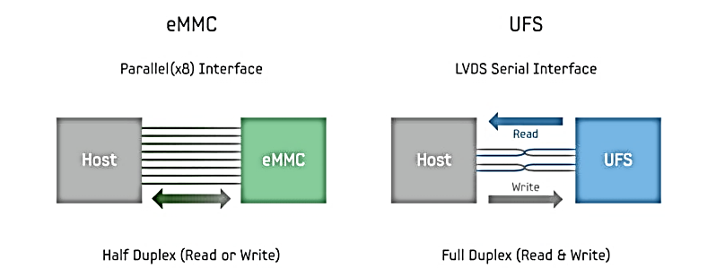

## **6.0 Solid State Drive(SSD)**

• SSD is an PC storage device that uses Solid State memory to store information.

• SSD uses non volatile NAND Flash Memory , which enables it to retain data when the power is removed.

* SSDs do not have any moving mechanical components, which distinguishes them from traditional magnetic disks such as hard disk drives (HDDs).
* **SSDs use NAND-based flash memory or DRAM to store data.**

## **6.1 Difference**

|  |  |
| --- | --- |
| * **Flash memory-based SSDs:** | * **DRAM-based SSDs:** |
| * use non-volatile NAND flash memory * Ability to retain the data without a constant power supply * lower cost compared to DRAM * Flash memory SSDs are slower than DRAM solutions. | * Based on volatile memory such as DRAM * internal battery or an external AC/DC adapter is needed to hold the data * ultrafast data access * primarily to accelerate applications |

**Assignment:**

* **Difference between SSD and Harddisk**
* **Advantage and disadvantages of SSD and harddisk**

## **6.2 RAID(Redundant Array of Independents Disks)**

RAID (**Redundant Array of Independents Disks**) is a simple technology that improves the performance of external storage solutions. RAID allows you to choose the best way to use your device to fit your needs. Simply put, RAID technology either divides or duplicates the task of one hard disk between many (or as few as two) disks to either improve performance or create data redundancy in case of a drive failure. You can decide how the device handles data by setting its RAID mode.

**To better understand how RAID works, first familiarize yourself with the terms below:**

**Striping✦✦**

is the splitting of data between multiple drives. Striped RAID arrays generally aim to merge maximum capacity into one single volume.

**Mirroring✦✦**

is the copying of data to more than one disk. Mirrored RAID arrays typically allow the failure of at least one disk in the array without any data loss, depending on the RAID level of the array.

**Fault Tolerance✦✦**

allows a RAID array to continue working (i.e. the data stored in the array is still available to the user) in the event of a disk failure. Not all mirrored RAID arrays are user friendly. For instance, some RAID devices must be shut down before a failed disk is replaced.

**RAID LEVELS**

* **RAID 0**
* **RAID 1**
* **RAID 2**
* **RAID 3**
* **RAID 4**
* **RAID 5**
* **RAID 6**
* **RAID 10(1+0)**

## **6.3 RAID 0**



* It is the fastest RAID mode.
* Requiring at least 2 drives, RAID 0 stripes data onto each disk. The available capacities of each disk are added together so that one logical volume mounts on the computer.
* If one physical disk in the array fails, the data of all disks becomes inaccessible because parts of the data have been written to all disks.**RAID 1.**



* It is a secure RAID mode that requires at least 2 drives and works with pairs of drives.
* One logical volume mounts on the computer and the combined available capacity of both drives is limited to the capacity of the lowest-capacity disk.
* If one physical disk fails, the data is available immediately on the second disk. No data is lost if one disk fails.

## **6.4 RAID 5**



* RAID 5 combines the striping of RAID 0 with data redundancy in an array with a minimum of three disks.
* Data is striped across all disks and a parity block (P) for each data block is written on the same stripe. If one physical disk fails, the data from the failed disk can be rebuilt onto a replacement disk.
* No data is lost in the case of a single disk failure, but if a second disk fails before data can be rebuilt to a replacement drive, all data in the array will be lost.

## **6.5 Nested RAID Levels**



**RAID 0+1**

* **RAID 0+1 is a secure RAID mode that is composed of a mirror of striped sets.**
* **Up to two disks can fail in a RAID 0+1 array without loss of data, as long as the failed disks are not part of different RAID 0 pairs.**

## **6.6 RAID config in BIOS**

**Press ctrl+I at the time of booting to get RAID utility in order to configure RAID**





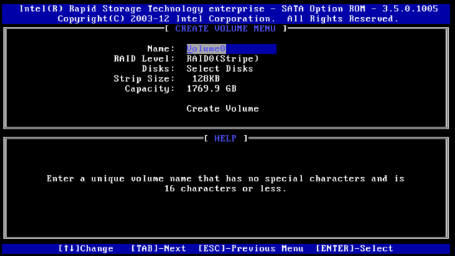

**Fig-9:Bios utility for RAID configuration**